

User Manual

GENIVI Traffic Incidents - Proof of Concept

Version: 1.1
Date: 5 December 2013
Authors: P. Goedegebure (TomTom)

SPDX-License-Identifier: CC-BY-SA-4.0

Copyright (C) 2014, TomTom International B.V.

This work is licensed under a Creative Commons Attribution-ShareAlike 4.0 International License

To view a copy of this license, visit http://creativecommons.org/licenses/by-sa/4.0/
or send a letter to Creative Commons, 444 Castro Street, Suite 900,
Mountain View, California, 94041, USA.
History

Rev. | Date | Status | Author | Change
1.0 | 19 June 2013 | Proposal | Peter Goedegebure | Document created
1.1 | 5 Dec 2013 | Accepted | Peter Goedegebure | Name of TrafficIncidentsUpdates interface changed to TrafficIncidentFeed.

Table of Contents
1 Introduction 5
1.1 Notation 5
2 Description of the application 5
2.1 Overview 5
2.2 TrafficIncidentsFeed 7
2.2.1 Components 7
2.2.2 Message set 8
2.2.3 Message sequence 13
2.3 TrafficIncidentsService 13
2.4 TrafficIncidentsConfiguration 14
2.5 TrafficIncidentsListClient 16
2.5.1 Overview 16
2.5.2 Functionality 17
2.5.3 UI description 19
2.6 TrafficIncidentsMapClient 20
2.6.1 Overview 20
2.6.2 Functionality 21
2.6.3 UI description 22
2.7 TrafficIncidentsWarningClient 22
2.7.1 Overview 22
2.7.2 Functionality 23
2.7.3 UI description 24
3 Installing and running the application 24
3.1 System requirements 24
3.2 The installer 24
3.3 Running the POC 25

Introduction

This document is a manual for the GENIVI Traffic Incidents - Proof of Concept. It describes the functionality (the UI and of the most relevant D-Bus messages used) and how to install and run the application.

Notation
For D-Bus calls and signals, this document uses the same pseudo-IDL as used in the D-Bus Specification.
Quote from this specification:

Here is an example of a method call:

org.freedesktop.DBus.StartServiceByName (in STRING name, in UINT32 flags,
out UINT32 resultcode)

This means INTERFACE = org.freedesktop.DBus, MEMBER = StartServiceByName, METHOD_CALL arguments are STRING and UINT32, METHOD_RETURN argument is UINT32. Remember that the MEMBER field can't contain any '.' (period) characters so it's known that the last part of the name in the "IDL" is the member name.

Description of the application

Overview
The following diagram shows the components of the POC.
TrafficIncidents
ListClient
TrafficIncidentsService
TrafficIncidents/
TrafficIncidentsListener
TrafficIncidents
Configuration
TrafficIncidents
MapClient
TrafficIncidents
WarningClient
D-Bus
BroadcastFramework
Implementation
TestPlayer
TecService
Dummy
BroadcastChannel
TpegSfwRefImpl
BroadcastAdaptation
LayerImplementation
TrafficIncidentFeed/
TrafficIncidentFeedListener
D-Bus
TpegTecFeed
RefImpl
TrafficIncidentsFeed
TestDatabase
OpenStreetMap
Dummy
Feed
In this diagram the single arrows represent data flows. The bold double arrow connectors represent D-Bus connections.
The following top level components are separate Java applications, which each run in their own virtual machine and only exchanging information via D-Bus:

- TrafficIncidentsService
A prototype implementation of the Traffic Incidents Service, the GENVI Abstract Component for which this Proof of Concept is meant to show that the interfaces are usable.

- TrafficIncidentsFeed
A complete simulation of a TPEG-TEC broadcast channel. The TestPlayerTecService cycles through a few hard coded TPEG-TEC messages. Via the BroadcastFrameworkImplementation, the DummyBroadcastChannel, the BroadcastAdaptationLayerImplementation, the TpegSfwRefImpl and the TpegTecFeedRefImpl these messages arrive as Traffic Incidents at the TrafficIncidentsService.
Also a DummyFeed is registered. This Feed doesn’t provide any Traffic Incidents. It’s only there to show status information for more than one Feed.
Details of this component are given in section 2.2.

- TrafficIncidentsConfiguration
This client of the TrafficIncidentsService configures the services. It installs Icons, IconSets and Categories. Details of this component are given in section 2.4.

- TrafficIncidentsListClient
This client of the TrafficIncidentsService presents the current Traffic Incidents in 3 textual formats. It uses the Updates signal to react to changes.
This client depends on the configuration (categories and icons) provided by TrafficIncidentsConfiguation. Details of this component are given in section 2.5.

- TrafficIncidentsMapClient
This client of the TrafficIncidentsService shows the locations of the current Traffic Incidents on a map display. Instead of using the Updates signal to react to changes, it just requests the current set of Traffic Incidents with a fixed interval.

- TrafficIncidentsWarningClient
This client of the TrafficIncidentsService simulates a pop-up with warnings to the user. It uses the Updates signal, specific for Traffic Incidents with a Warning Level higher than INFORMATIVE, to react to changes. The window is only visible if there are warnings to show. Details of this component are given in section .

Besides these Java applications there is a:
- TestDatabase
A small map database, teleatlas_utrecht_2008_04.db3, to be able to decode OpenLR locations.
This is a map database from the 4th quarter of 2008, covering an area around Utrecht in the Netherlands.

TrafficIncidentsFeed

Components
As it is the intention to also define Abstract Components for the TPEG Service Framework (TpegSfw) and TPEG Applications, this feed is already structured to represent the foreseen architecture.
This section describes the components of the TrafficIncidentsFeed. If you only want to run the POC (and judge the functionality) you can skip this section.
Because the focus is on functionality and data models, Java objects are transferred between all components, where in a real implementation binary data would be transferred between most of the components.
The TestPlayerTecService and the BroadcastFrameworkImplementation represent a broadcaster of TPEG data, so they are not part of the IVI system.
The components of the TrafficIncidentsFeed can best be described bottom up.

DummyBroadcastChannel
This component is a very simple representation of the combination of a radio transmitter and a radio receiver. The only thing that is modelled is that you put data in on one side (broadcast) and get it out on the other side (dataRecieved). Like in a real broadcast, many receivers can receive the same broadcasted information.
The unit of information that is broadcasted is a Java object, which in this case is TPEG Transport Frame.

BroadcastFrameworkImplementation
This component represents the common part of TPEG on the broadcast side. This component gathers information from various TPEG Applications, packs the information in TPEG Transport Frames, and broadcasts the information over the DummyBroadcastChannel.
This specific implementation:
- Gathers and broadcasts the information every 5 seconds
- It gathers TPEG-TEC information from the TestPlayerTecService
- It has a built-in SNI application, supplying the minimal required information

TpegSfwRefImpl
This component represents the GENIVI component TpegServiceFramework, which is meant to become an Abstract Component in the future. It receives TPEG Transport Frames, from which the Service Component Frames are extracted and passed on to the related TPEG Application handlers (like in this case the TpegTecFeedRefImpl for TPEG-TEC).
This component itself contains a simple implementation for the TPEG-SNI application.
This component is the client side counterpart of the server side BroadcastFrameworkImplementation.

TestPlayerTecService
This component represents a TPEG-TEC application on the broadcast side. This service generates a fixed sequence of hard coded TPEG messages. On request, these messages are handed over to the BroadcastFrameworkImplementation. The messages are described in section 2.2.2, the sequence of the messages is described in section 2.2.3.

TpegTecFeedRefImpl
This component is a prototype implementation of the TpegTecFeed.component. It receives Service Component Frames (as Java objects) from the TpegSfwRefImpl. The received information is converted into Traffic Incidents and passed on to the TrafficIncidentsService via the TrafficIncidentFeed interface.
DummyFeed
This is not a real Feed. It is registered as a Feed, but never provides any Traffic Incidents or changes in the status information. It’s only there to show status information (in the TrafficIncidentsListClient) for more than one Feed.

Message set
The TestPlayerTecService has 3 different messages. In this document, the messages are referred to by their name, which has the format message<xxxx>, where <xxxx> is the messageID of the message.
Note that these are TEC messages to be ‘transmitted’, so this description is fully according to TPEG-TEC (and not according the Traffic Incident data model used in the API of the TrafficIncidentsService).

message1234
This is a minimal message, with only an effectCode and a location reference.
The complete content of the message is shown in the following figure.

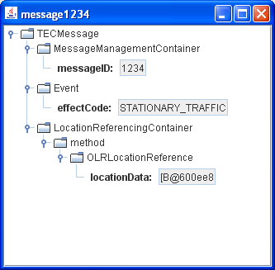

Message4567
This is a complex message with 2 causes and 2 vehicle restrictions.
The following figure shows an overview of the message.
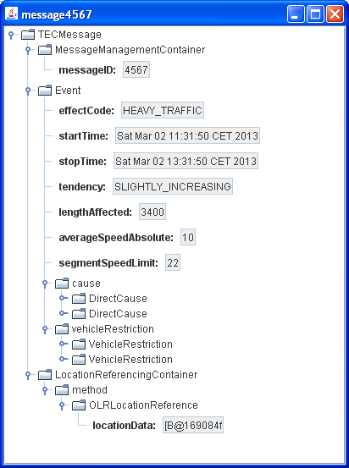

The following figure shows the details of the causes.

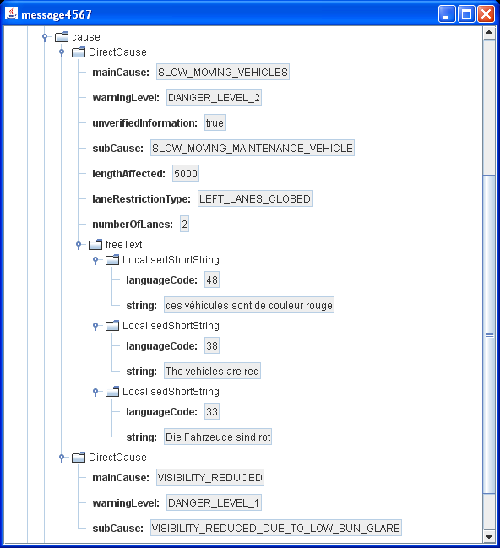

The following figure shows the details of the vehicle restrictions.

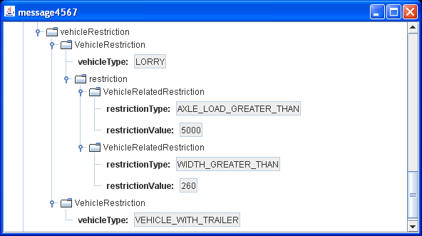

message7878
This is a message with a single cause and 3 advices.
The complete content of the message is shown in the following figure.

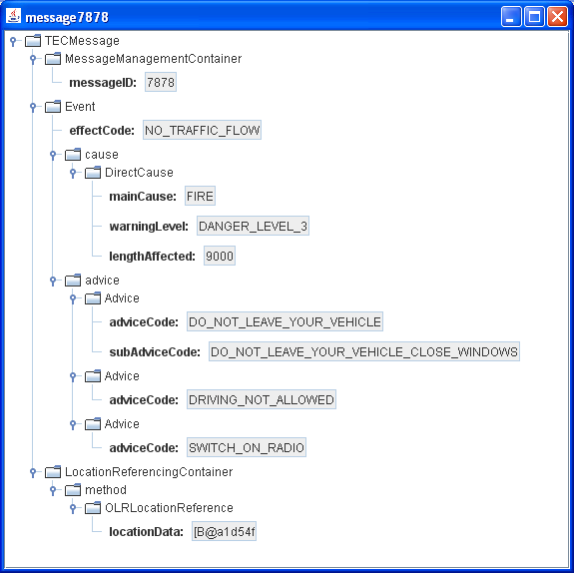

Message sequence
The TestPlayerTecService responds to requests from the BroadcastFrameworkImplementation according to a fixed, repeated sequence:
- request 1
  - new message: message1234
- request 2
  - cancel message: message1234
  - new message: message4567
- request 3
  - new message: message7878
- request 4
  - cancel messages: message7878, message4567

TrafficIncidentsService
This prototype implementation of the TrafficIncidentsService in principle fully implements the TrafficIncidents interface and TrafficIncidentFeed interface. So all functionality can be tested.
Known restrictions:
- Only OpenLR location references are supported
As the included test database only contains a small area around Utrecht in the Netherlands, only locations in this area can be decoded.
- Very basic text generator
The implementation contains a very basic text generator. The sentences produced don’t look very nice, but they should contain all relevant information.

TrafficIncidentsConfiguration
This client of the TrafficIncidentsService configures the services. It installs Icons, IconSets and Categories. The installed Icons and IconSets are visualized in the following figure.

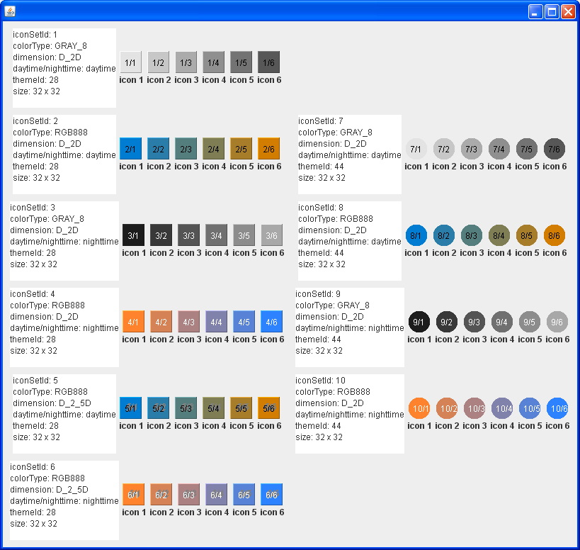

This client has no GUI.
The following actions are performed:
- Reserve Icon Set Ids
As there will be 10 Icon Sets defined, 10 Ids are reserved by calling:
org.genivi.TrafficIncidentsService1.TrafficIncidents.ReserveIconSetIds(
in INT32 numberOfIds, out INT32[] iconSetIds)
- The Icon Sets, with Icon Descriptors, are created with the received iconSetIds.
- For each Icon Descriptor of each Icon Set, an icon is generated.
This leads to the information as shown in the figure above.
- Inject the Icon definitions into the TrafficIncidentsService.
This is done with the call:
org.genivi.TrafficIncidentsService1.TrafficIncidents.AddIconDefinitions(
in IconDefinitionStruct[] iconDefinitions)
- Inject the Icon Set definitions into the TrafficIncidentsService.
This is done with the call:
org.genivi.TrafficIncidentsService1.TrafficIncidents.AddIconSetDefinitions(
in IconSetDefinitionStruct[] iconSetDefinitions)
It is important to inject the Icons definitions first and then the Icon Set definitions, because another client can request the information at any moment.
- Reserve category Ids
As there will be 3 categories defined, 3 Ids are reserved by calling:
org.genivi.TrafficIncidentsService1.TrafficIncidents.ReserveCategoryIds(
in INT32 numberOfIds, out INT32[] categoryIds)
- The category definitions are created with the received categoryIds.
The category definitions are shown in the figure below.
- Inject the Category definitions into the TrafficIncidentsService
This is done with the call:
org.genivi.TrafficIncidentsService1.TrafficIncidents.AddCategoryDefinitions(
in CategoryDefinitionStruct[] categoryDefinitions)
- Configuration is done and the client exits.

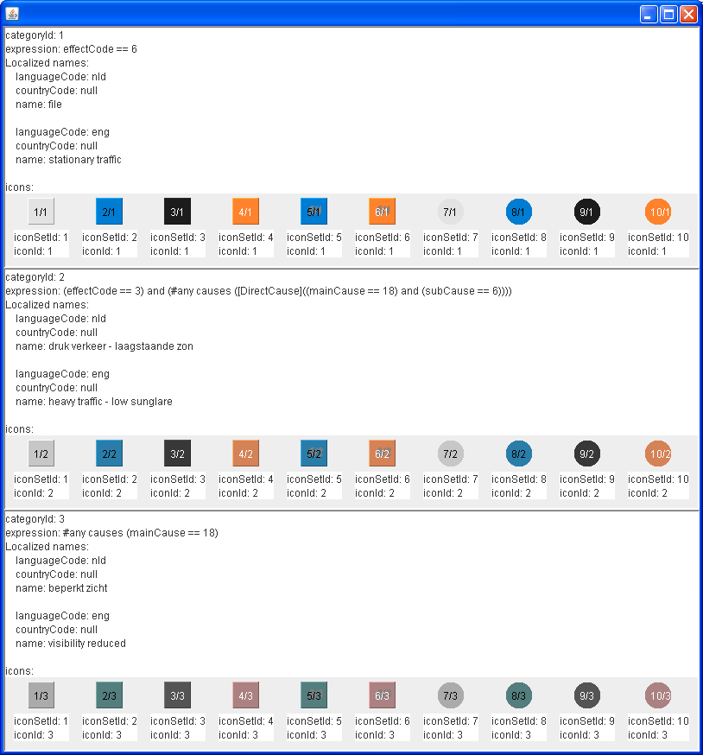

TrafficIncidentsListClient

Overview
This client of the TrafficIncidentsService shows:
- Asynchronous use of the TrafficIncidents interface
During initialization, as far as possible, requests are sent in parallel.
During normal operation, requests for information on Traffic Incidents are sent in parallel.
A signal is used to be notified on changes in the Traffic Incidents.
- How a client can use categories and icons, using only information obtained from the TrafficIncidentsService.
- The flexibility of the interface for showing textual information to the user.
- How status information can be presented to the user.

The screen of the list client is shown in the following figure.

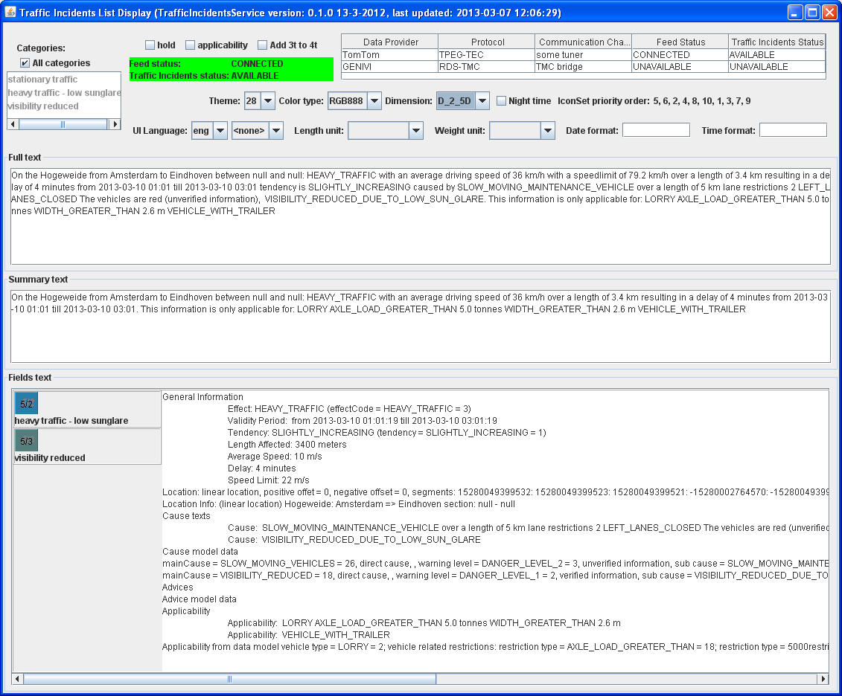

Functionality
The list client performs the following actions.

Initialization
To show the asynchronous nature of the TrafficIncidents interface, the following actions are performed in parallel as much as possible (only if the text below mentions ‘if’, it implies that something has to be done after other information is already received).
- Get the interface version
The interface version information is obtained by calling:
org.genivi.TrafficIncidentsService1.TrafficIncidents.GetVersion(
out Version version)
A real client of the TrafficIncidentsService would check the obtained version with the required version. This demo client just shows the version information in the title bar.
- Get the currently used language
In a real system, there would be one client responsible for setting the language during start-up. This demo client starts with the default language of the TrafficIncidentsService. This current language is obtained by calling:
org.genivi.TrafficIncidentsService1.TrafficIncidents.GetLanguage(
out STRING languageCode, out STRING countryCode)
The received information is used to update the ‘UI Language’ controls.
- Get the defined Icon Sets
This is done by calling:
org.genivi.TrafficIncidentsService1.TrafficIncidents.GetIconSets(
out IconSet[] iconSets)
The Icon Sets are used to select the kind of icon to show per Traffic Incident Category.
- Get the Icon Definitions
It is possible that part of the icons have to be read from files and the others are to be obtained from the TrafficIncidentsService. This implementation however assumes a single source for the icons (which is in line with the functionality of TrafficIncidentsConfiguration). Therefore, if the url is set for any Icon Descriptor of any Icon Set, the icons will be read from files.
If the icons are not read from files, they are obtained from the TrafficIncidentsService, by calling:
org.genivi.TrafficIncidentsService1.TrafficIncidents.GetIconDefinitions(
in IconInfo[] iconInfos, out IconDefinition[] iconDefinitions)
Where iconInfos is an empty array, to get all the Icon Definitions.
- Get the Category Definitions
The Category Definitions are obtained by calling:
org.genivi.TrafficIncidentsService1.TrafficIncidents.GetCategoryDefinitions(
out CategoryDefinition[] categoryDefinitions)
- Register for changes in the Traffic Incidents Status
This is done by starting to listen to the TrafficIncidentsStatus signal by calling:
org.genivi.TrafficIncidentsService1.TrafficIncidents. AddTrafficIncidentsStatusListener()
- Register for changes in the Feed Information
This is done by starting to listen to the FeedInformation signal by calling:
org.genivi.TrafficIncidentsService1.TrafficIncidents. AddFeedInformationListener ()
- If the client is ready to handle Traffic Incidents, it will subscribe to Traffic Incident updates by calling:
org.genivi.TrafficIncidentsService1.TrafficIncidents.AddUpdateListener(
in INT32 listenerId, in WarningLevel[] warningLevels, in INT32[] categoryIds)
Where:
listenerId is a unique number (typically 1), generated by this client.
warningLevels is an empty list (so any Warning Level)
categoryIds is an empty list (so any Category Id)
The client is ready to handle Traffic Incidents if the following information is available: Version, Icon Sets, Icon Definitions and Category Definitions.

Handling changes in the Traffic Incidents
If there are changes in the Traffic Incidents:
- An Update() signal is received:
Updates(
out INT32 listenerId,
out INT32[] unchangedTrafficIncidentIds,
out INT32[] changedTrafficIncidentIds,
out INT32[] newTrafficIncidentIds,
out INT32[] deletedTrafficIncidentIds)
- As this application fully redraws the text panels, it will request information for all current incidents, which is a combination of the unchanged, changed and new incidents.
Three requests are sent for the three text panels:
org.genivi.TrafficIncidentsService1.TrafficIncidents.getTexts(
in INT32[] currentIncidentIds, in TextDetailLevel FULL,
out STRING[] texts)
org.genivi.TrafficIncidentsService1.TrafficIncidents.getTexts(
in INT32[] currentIncidentIds, in TextDetailLevel SUMMARY,
out STRING[] texts)
org.genivi.TrafficIncidentsService1.TrafficIncidents. getTrafficIncidents(
in INT32[] currentIncidentIds, in BOOLEAN true,
out TrafficIncident[] trafficIncidents)
- The <update-time> in the Title bar is set to the current time.
- Received texts are shown in the ‘Full texts panel’ and ‘Summary texts panel’ as applicable.
- For the received TrafficIncidents the categoryIds in the incident are used to show the icons and the complete contents of the data model is shown in a textual format.

UI description
From top to bottom and left to right the screen consists of:
- Title bar
The title has the following format:
Traffic Incidents List Display (TrafficIncidentsService version :<version>, last updated: <update-time>)
Where:
<version> is the version information obtained from the TrafficIncidentsService.
<update-time> is the date/time at which the last update signal was received.
- Category selection
If the checkbox ‘All categories’ is checked, the text panels show the Traffic Incidents for any category.
If the checkbox is not checked, any number of categories can be selected. In this case the text panels only show Traffic Incidents which have at least one of the specified categories.
Selecting none of the categories in this list, is the same as having the checkbox checked, because in the TrafficIncidents interface an empty list means ‘all categories’.
On any change in the category selection, RemoveUpdateListener() is called, followed by calling AddUpdateListener() with the right list of category Ids.
- Control checkboxes
These are the following checkboxes:
  - hold
If this checkbox is checked, the text panels are no longer updated. The update signal is still received (leading to an updated time in the Title bar), but no requests for Traffic Incident information are sent to the TrafficIncidentsService and so the text panels are not updates.
This functionality is only there to be able to study the contents of the text panels.
  - applicability
If this checkbox is checked, the applicability expression is set.
If the ‘Add 3t to 4t’ checkbox is not checked, the axle load of the vehicle is assumed to be 4 tons. In this case the expression is:
(#list applicability (^count > 0)) and (#all applicability (@ (((^isSet(vehicleType)) and (vehicleType != 2)) or (#any vehicleRelatedRestrictions (@ (((restrictionType == 17) and (restrictionValue < 4000)) or ((restrictionType == 18) and (restrictionValue > 4000))))))))
If the ‘Add 3t to 4t’ checkbox is checked, 3 tons are added to the axle load, leading to the expression:
(#list applicability (^count > 0)) and (#all applicability (@ (((^isSet(vehicleType)) and (vehicleType != 2)) or (#any vehicleRelatedRestrictions (@ (((restrictionType == 17) and (restrictionValue < 7000)) or ((restrictionType == 18) and (restrictionValue > 7000))))))))
The applicability is set by calling:
org.genivi.TrafficIncidentsService1.TrafficIncidents. setApplicability (
in String filterExpression)
  - Add 3t to 4t
If this checkbox is checked, and the applicability checkbox is checked, 4 tons are added to the default axle load of 3 tons. See ‘applicability’ above.
- General Feed Status
Provides the ‘Feed status’ and ‘Traffic Incidents status’ across all feeds.
This information is updated each time the TrafficIncidentsStatus() signal is received.
- Status per feed
Provides the status information per feed in a table. Each row in the table represents one Feed. The first row is the TrafficIncidentsFeed, the second row is the DummyFeed.
This information is updated each time the FeedInformation() signal is received.
- Icon selection
Here the icon preferences can be specified. It is possible to select an icon Theme, a Color Type, the Dimension and Night time (instead of day time).
Derived from this the application calculates a priority order for selecting the icon to be shown for a specific category.
Changing the icon preferences doesn’t change the currently shown icons in the ‘Fields text’ panel. Only when new data is received, the panel is updated.
- Language selection
For the UI language, a language code and a country code can be selected. Any change is directly sent to the TrafficIncidentsService.
The text panels are only updated if there are changes in the Traffic Incidents.
On any change there’s a call to:
org.genivi.TrafficIncidentsService1.TrafficIncidents. setLanguage(
in STRING languageCode, in STRING countryCode)
- Message format control
To customize the text information of the Traffic Incidents it is possible to set the ‘Length unit’, ‘Weight unit’, ‘Date format’ and ‘Time format’.
Any change is directly sent to the TrafficIncidentsService.
The text panels are only updated if there are changes in the Traffic Incidents.
The related calls are:
org.genivi.TrafficIncidentsService1.TrafficIncidents. SetLengthUnit(
in LengthUnit lengthUnit)
org.genivi.TrafficIncidentsService1.TrafficIncidents. SetWeightUnit(
in WeightUnit weightUnit)
org.genivi.TrafficIncidentsService1.TrafficIncidents. SetTimeFormat(
in STRING timeFormat)
org.genivi.TrafficIncidentsService1.TrafficIncidents. SetDateFormat(
in STRING dateFormat)
- Full texts panel
This panel shows the ‘Full Text’ for each of the current Traffic Incidents.
- Summary texts panel
This panel shows the ‘Summary Text’ for each of the current Traffic Incidents.
- Fields texts panel
On the left this panel shows the icon and name for each category assigned to the Traffic Incident.
On the right all the information of the data model is shown. Where applicable (like e.g. for Effect) both the text from the data model and the value from the data model are shown.
For all numerical values (speed, distance, time, etc.) formatting is done by this application.

TrafficIncidentsMapClient

Overview
This client of the TrafficIncidentsService shows the locations of the current Traffic Incidents on a map.
- The Traffic Incidents are obtained every 3 seconds.
- The map display shows information from OpenStreetMap
- The location can be drawn based on the Location, or the LocationInfo in the Traffic Incident.
- The boundBox in the Traffic Incident can be shown.
- It is possible to apply an area filter.

An example picture of the UI is shown in the following figure.

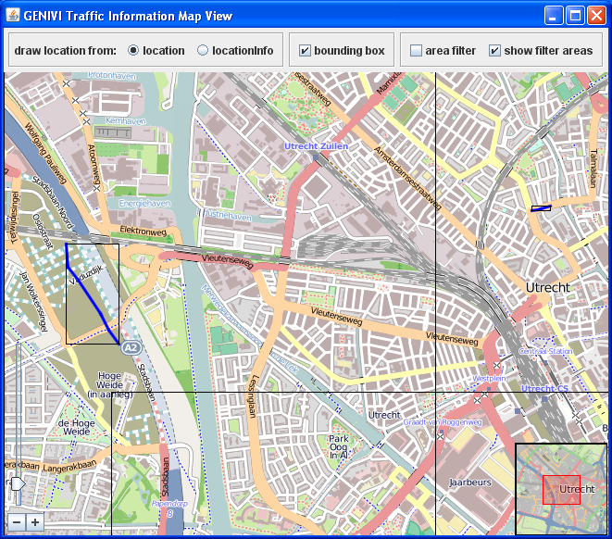

Functionality
Every 3 seconds a request for the current Traffic Incident Ids is sent to the TrafficIncidentsService.
If the area filter is not active the request is:
org.genivi.TrafficIncidentsService1.TrafficIncidents. GetTrafficIncidentIds (
in WarningLevel[] warningLevels, in INT32[] categoryIds,
out INT32[] trafficIncidentIds)
where warningLevels and categoryIds are both empty lists.

If the area filter is active the request is:
org.genivi.TrafficIncidentsService1.TrafficIncidents. GetTrafficIncidentIdsInAreas (
in WarningLevel[] warningLevels, in INT32[] categoryIds,
in RectangularArea[] areas,
out INT32[] trafficIncidentIds)
again warningLevels and categoryIds are both empty lists. areas is an array of 2 rectangular areas: [((52.08, 5.06, 0),(52.11, 5.10, 0)), ((52.07, 5.07, 0), (52.09, 5.15, 0))].

When the trafficIncidentIds are received, the details of the incidents are obtained by calling:
GetTrafficIncidents (
in INT32[] trafficIncidentIds, in BOOLEAN includeTextFields,
out TrafficIncident[] trafficIncidents)

where includeTextFields is false, as here we’re not interested in textual information.

When the trafficIncidents are received, their locations are drawn on the map. The drawn location can be based on the Location of the LocationInfo.
- Location
For each segment the coordinates of the start and end node are obtained from the database and a line is drawn between these points.
The offsets are not handled in this implementation.
The location is drawn in blue.
- LocationInfo
Lines are drawn between the coordinates in the list of coordinates.
The location is drawn in red.

UI description
The UI provides the following controls:
- Draw location from
  - location
The lines on the map are drawn based on the location in the Traffic Incidents. For this the application needs map database access (in this case the TestDataBase).
The lines are blue.
  - locationInfo
The lines on the map are drawn based on the locationInfo in the Traffic Incidents. For this no map database access is needed.
The lines are red.
- boundingBox
If checked, the locationBoundingBox in the Traffic Incident is drawn.
- areaFilter
If checked, an array of two area filters is used in the request for the current Traffic Incidents.
- Show filter areas
If checked, the areas of the area filters are shown on the map.
The controls determine the settings for the next request for Traffic Incidents and for drawing the information on the map, so there will be a delay between changing a setting and seeing the result on the map.
The map provides standard controls for panning and zooming.

TrafficIncidentsWarningClient
In this section we’ll refer to all Traffic Incidents with a Warning Level higher than INFORMATION as ‘severe’ incidents.

Overview
This client of the TrafficIncidentsService shows:
- How a client can be informed about severe Traffic Incidents.
- That a client can request only required parts of a Traffic Incident.

An example picture of the UI is shown in the following figure.
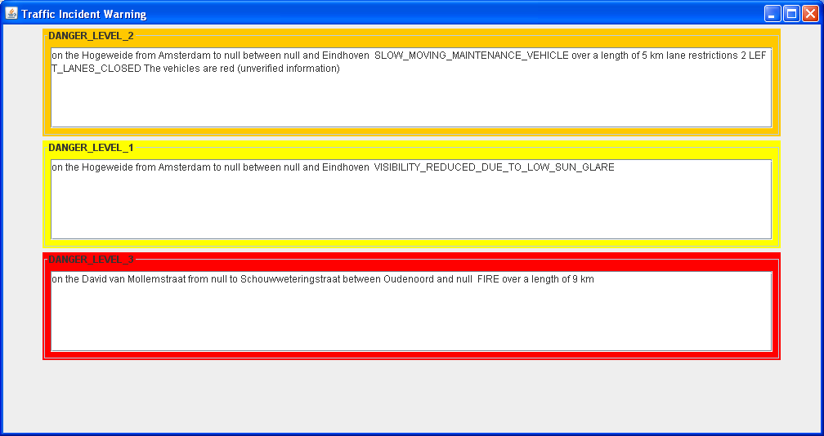

Functionality
The client subscribes itself to Traffic Incident updates by calling:
org.genivi.TrafficIncidentsService1.TrafficIncidents.AddUpdateListener(
in INT32 listenerId, in WarningLevel[] warningLevels,
in INT32[] categoryIds)
Where:
listenerId is a unique number (typically 1), generated by this client.
warningLevels is a list with all warning levels above INFORMATION.
categoryIds is an empty list (so any Category Id)

If there are changes in the severe Traffic Incidents:
- An Updates() signal is received:
Updates(
out INT32 listenerId,
out INT32[] unchangedTrafficIncidentIds,
out INT32[] changedTrafficIncidentIds,
out INT32[] newTrafficIncidentIds,
out INT32[] deletedTrafficIncidentIds)
- As this application fully redraws the text panels, it will request information for all current, severe, incidents, which is a combination of the unchanged, changed and new severe incidents.
As only specific information of the incidents is needed, the function GetTrafficIncidentsFields() is used to obtain the needed information:
org.genivi.TrafficIncidentsService1.TrafficIncidents. getTrafficIncidentsFields(
in INT32[] currentIncidentIds,
in TrafficIncidentField[] trafficIncidentFields,
out TrafficIncident[] trafficIncidents)
where trafficIncidentFields contains the fields: CAUSES, CAUSE_TEXTS and LOCATION_INFO.
- For each Traffic Incident, each severe Cause is displayed in a separate box. For each Cause the following information is shown:
  - Location Info (using the field LOCATION_INFO)
  - The Cause text (using the field CAUSE_TEXTS)
  - The Warning Level (using the field CAUSES)

UI description
The UI has no controls. If there are no severe Traffic Incidents, the window is hidden, otherwise is it shown (simulating a pop-up).
Each severe Cause is shown in a separate box. The border color and title of the box indicate the Warning Level.
For each Cause the LocationInfo and Cause are shown.
Please note that a single Traffic Incident can have more than one Cause. So one incident can lead to more than one warning (which is the case for Message4567).

Installing and running the application

System requirements
This Proof Of Concept is a Java application making use of D-Bus. It will typically run on any Linux version with:
- D-Bus
- Java version 7
- The libraries: libunix-java.so, libcgi-java.so
It is however only tested on Ubuntu (and Lubuntu).

To get everything in place on Ubuntu:
- Add the apt repository for Oracle Java 7, by executing:
$ sudo add-apt-repository ppa:webupd8team/java
- Make apt aware of the new software repository, by executing:
$ sudo apt-get update
- Install Oracle Java 7, by executing:
$ sudo apt-get install oracle-java7-installer
- Check that you have Java 7, by executing:
$ java -version
- Install libunix-java.so, by executing:
$ sudo apt-get install libunixsocket-java
- Install libcgi-java.so, by executing:
$ sudo apt-get install libcgi-java
- Check that you have libunix-java.so and libcgi-java.so, by executing:
$ ls /usr/lib/jni

The installer
The POC is delivered as a Windows Installer: TomTom-GENIVI-TrafficIncidentsPOC-Installer.exe, so it has to be run on Windows.
This installer places all files of the POC in a ‘Destination folder’, which you can specify on the second screen of the installer. Typically this will be a ‘Shared folder’; a folder shared between Windows and Ubuntu.
The installer only writes files to the ‘Destination folder’, so:
- You can remove the POC by removing that folder
- You can zip this folder and unzip it somewhere else, e.g. on another Ubuntu machine, and it will still run.

The POC installation contains:
RunTrafficIncidentsPOC.sh A scripts which starts each component of the POC in a separate xterm.
resourrces/ Contains the TestDatabase.
Teleatlas_utrecht_2008_04.db3 The actual map database.
TrafficIncidentsConfiguration/ Contains the component TrafficIncidentsConfiguration.
RunTrafficIncidentsConfiguration.sh A script to start the TrafficIncidentsConfiguration component.
*.jar The jar files for this component.
TrafficIncidentsFeed/ Contains the component TrafficIncidentsFeed.
RunTrafficIncidentsFeed.sh A script to start the TrafficIncidentsFeed component.
*.jar The jar files for this component.
TrafficIncidentsListClient/ Contains the component TrafficIncidentsListClient.
RunTrafficIncidentsListClient.sh A script to start the TrafficIncidentsListClient component.
*.jar The jar files for this component.
TrafficIncidentsMapClient/ Contains the component TrafficIncidentsMapClient.
RunTrafficIncidentsMapClient.sh A script to start the TrafficIncidentsMapClient component.
*.jar The jar files for this component.
TrafficIncidentsService/ Contains the component TrafficIncidentsService.
RunTrafficIncidentsService.sh A script to start the TrafficIncidentsService component.
*.jar The jar files for this component.
TrafficIncidentsWarningClient/ Contains the component TrafficIncidentsWarningClient.
RunTrafficIncidentsWarningClient.sh A script to start the TrafficIncidentsWarningClient component.
*.jar The jar files for this component.

Running the POC

You can run the complete POC by executing the script RunTrafficIncidentsPOC.sh. This script starts each component of the POC in a separate xterm. Stopping and cleaning up has to be done manually.

It is of course also possible to start the individual components manually.
- Open a terminal
- Go to the folder of the component
- In that folder execute the script RunTrafficIncidents<component-name>.sh, <component-name> is the name of the component.
- Normally you would first run the TrafficIncidentsService.

